2013

**iShelter User Manual**

**A step by step guide**

**Weylin Renison**



iShelter User Manual

Table of Contents

About 3

Step By Step Guide 4

Adding an Animal to the System 4

Adding a Guardian 9

Booking\Adding a Procedure 11

During adding\adopting an Animal 11

After adding\adopting an Animal 13

Editing\Deleting 16

Reporting 18

Specific Animal Report 18

Adopted / Not Nuetred Report 19

Processed by specific Report 20

Finding Application Options 21

Finding this user manual again 22

Hold the Ctrl key and click on a chapter if you wish to jump to that chapter straight away.

# About

This Program was developed by Weylin Renison

iShelter v1.0

Credit To External Open Source Libraries

iTextSharp for pdf

WinFormCharpWebcam for webcam

wmgCMS for water mark Text Boxes

# Step By Step Guide

# Adding an Animal to the System

The very first time the iShelter application is opened, you will be prompted for a location where all files and reports will be saved in the future and also where the database exists for the application to use.

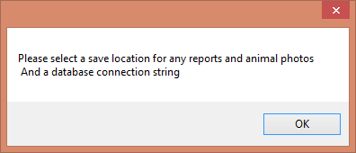

Click OK when prompted for this. The Options window will appear. Click on Browse to select a destination.

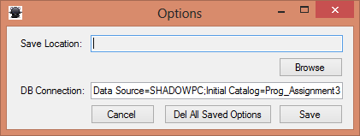The DB connection should all ready be in there otherwise contact your system administrator for the correct information.

After selecting a location you can now click save and the application will open.

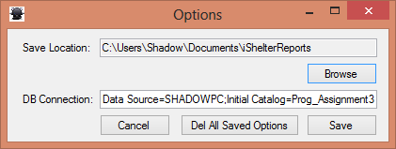

This is the window you will see from now on every time the application is opened.

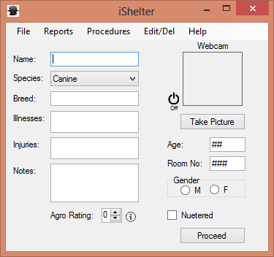This window will serve as the main landing page and can be used to enter an animal into the system.

Required fields include Name, Species, Breed, Age, Room No, Agro Rating and Nuetered.

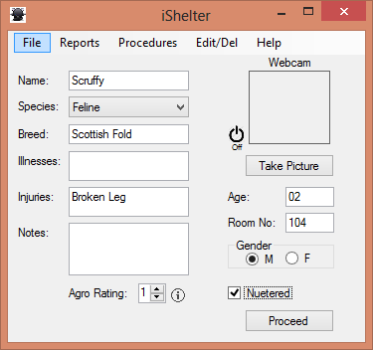Once the details of the animal has been completed, turn on the web cam by clicking on the on\off button next to the frame.

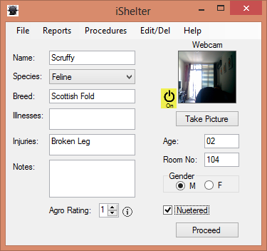

No arrange the animal in front of the camera and click the "Take Picture" button.

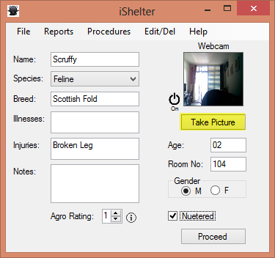

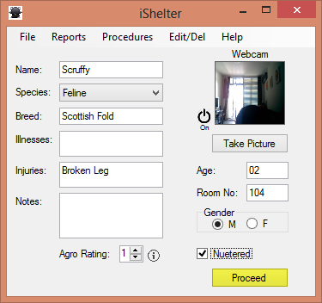The picture has now been taken, click on the "Proceed" button to continue.

PS If you are not sure about the agro rating scale you can always hover the mouse over the information icon to the right of the agro rating field. A scale will be shown.

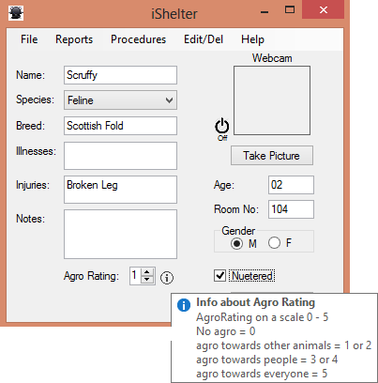

After clicking the proceed button you will now be made aware if the animal has been successfully 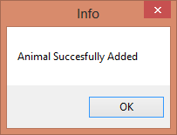been added into the system. Click OK at this point.

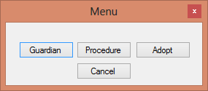After clicking ok you will now be prompted with a menu. From this menu you can select if you would like to add a guardians information for the newly added animal, add a procedure or Adopt the animal. You can always add a guardian or procedure for the animal at a later stage if you wish.

Let us assume you only want to adopt the animal and not book a procedure or a add a guardian. Simply click on the "Adopt" button and you will be taken back to the landing page.

PS: To see how this is done please refer to the chapters "Adding a Guardian" and "Booking a Procedure".

# Adding a Guardian

Please refer to the chapter on "Adding an animal to the System" for details on how to add\adopt an animal into the system.

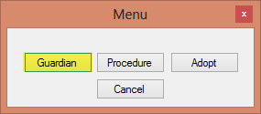A menu will be displayed after add the animal, click on the "Guardian" button.

A window will appear to enter the guardians details. If the guardian has not previous been registered with the shelter enter their details and click proceed.

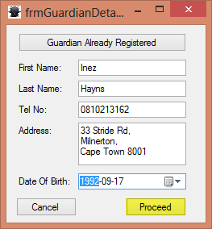

If the guardian has been registered previously click on the "Guardian Already Registered" button.

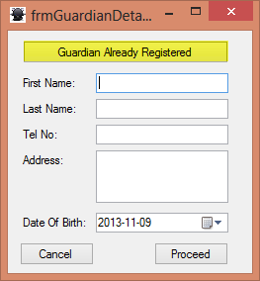

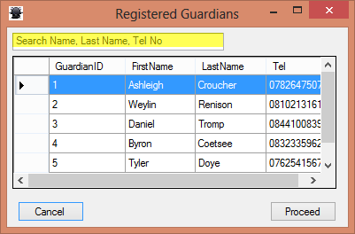You will now be presented with a list of previously registered guardians. You can use the search field at the top to enter their name, last name or telephone number to search for them.

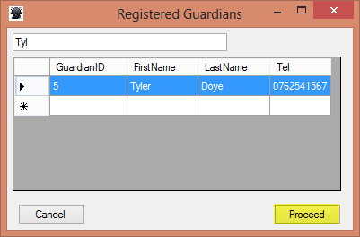Once you have found the guardian you are looking for you can select them by simply clicking anywhere in the row of that guardian. Then click proceed.

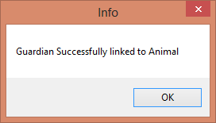You will now be informed that the guardian has successfully been linked\registered to the animal.

# Booking\Adding a Procedure

There are two way a procedure can be added, either during adding\adopting an animal or after.

## During adding\adopting an Animal

After adding an animal a menu window will be displayed. Click on procedure.

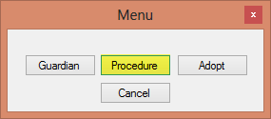

The animal for the procedure will already be selected for you. Now you can use the search field at the top to search for a specific procedure, select the procedure by clicking anywhere on the row.

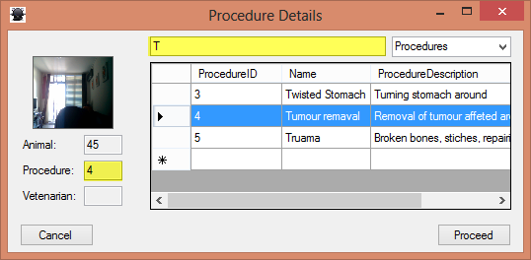

The selected procedure's ID will be displayed on the left, you can click a different procedure if you wish to change it. Now click on the drop down box in the top right corner to begin selecting a vetenarian for the procedure. Click on Vetenarians.

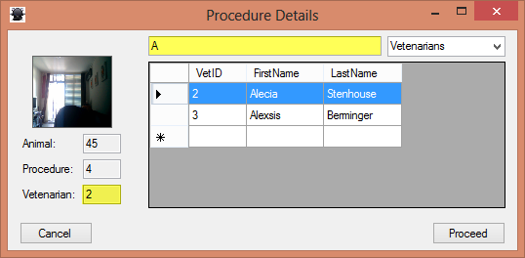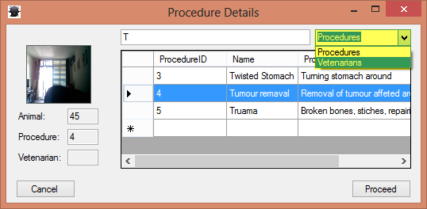

Now select a vetenarian just like you selected a procedure, by clicking anywhere on that vet's row. The Vet's ID will be displayed on the left.

Now click proceed. You will be notified that you procedure has been added.

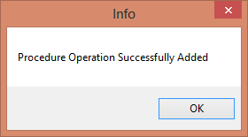

## After adding\adopting an Animal

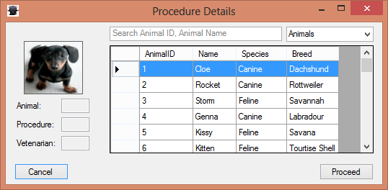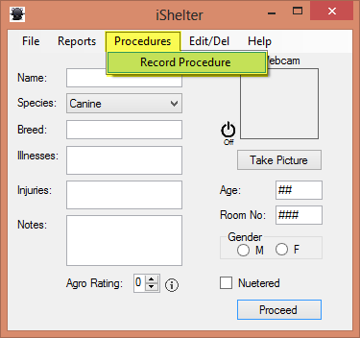From the home screen click on the Procedure menu the on Record Procedure.

You will now be presented with a list of all animals that have been added\adopted.

You can use the search field at the top to search for a particular animal you would like to add a procedure for. Select a animal by clicking anywhere in the row of that animal. The animal's ID will be displayed to the left. You can change which animal is selected by simply clicking on another animal.

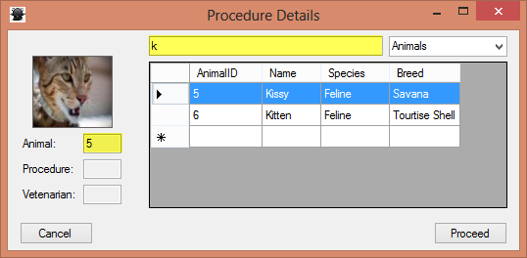

Now use the drop down box in the top right corner to and select Procedures to begin selecting a procedure for the animal.

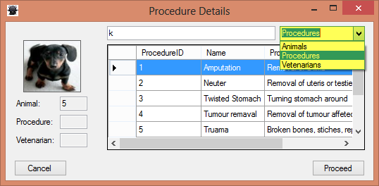The procedure is selected in exactly the same way you have done to select an animal.

Use the drop down box again to select Vetenarians to begin selecting a vet for the procedure.

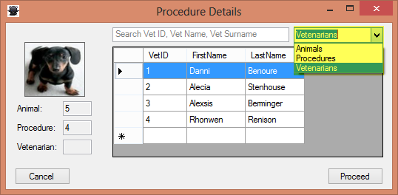Selecting a vet is done in the same way as before.

Now click proceed.

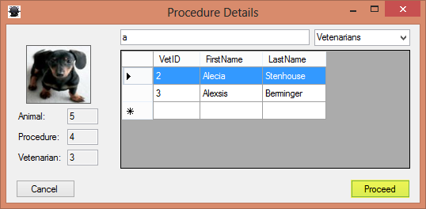

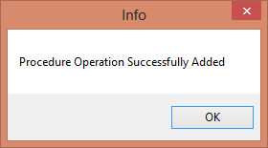You will be informed that the Procedure was successfully added. Click Ok and you will be returned to the home screen.

# Editing\Deleting

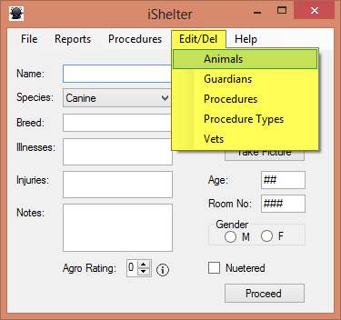From the home screen click on the Edit\Del menu and select what you would like to edit or delete. In this example we will choice animals, however you could choose any of the options and they will work in the same manner.

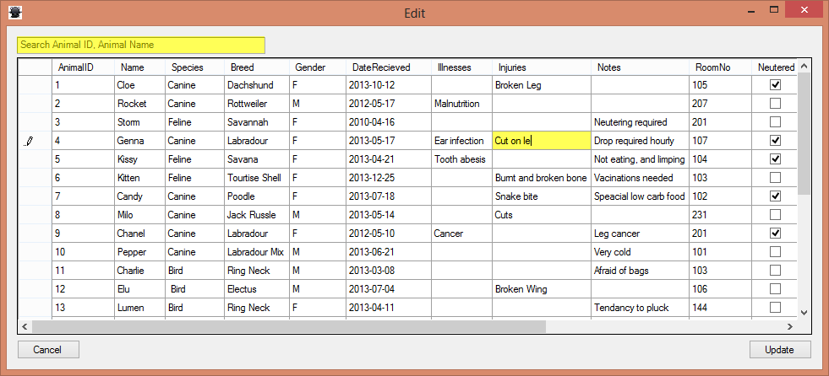A list of all the animals will now be displayed. You can now search a specific animal if you choice by using the search field at the top left. Click on a field you would like to edit, now change the value.

If you would like to delete an animal select the whole row by clicking on the select all block on the left and pressing the delete key on the keyboard. You may want to make numerous deletes, this can be done by clicking and dragging to the next boxes or holding the Ctrl key down while selecting specific animals to delete.

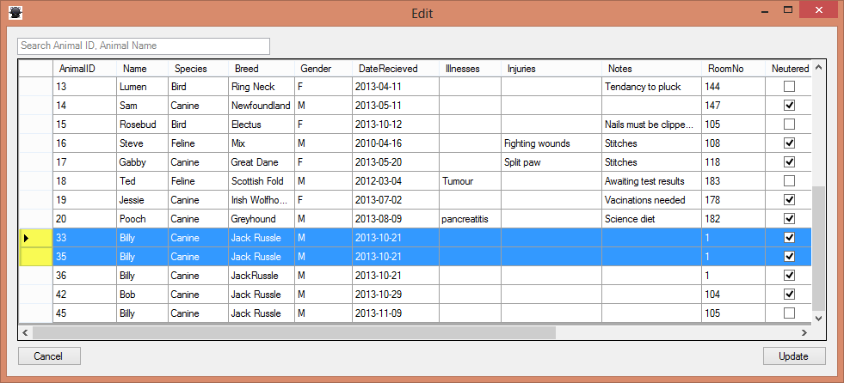

You may make numerous deletes and edits before you are satisfied, once you are done click on the "Update" button to commit these changes to the system.

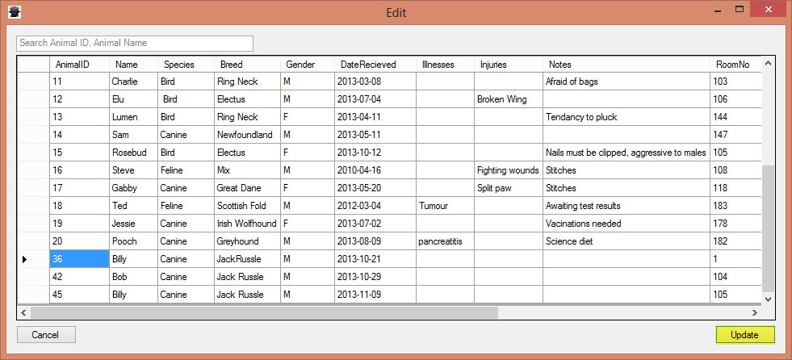

# Reporting

There are numerous reports that can be generated here is how they work and an explanation of what each is. To access a report click on the Reports menu and select which report you woul like to generate.

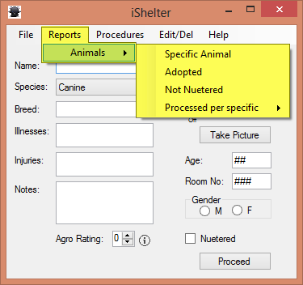

## Specific Animal Report

This report allows you to select a animal you would like a full detailed report on, once you have selected the report a list of all the animals in the system will be displayed. You can search for an animal by using the search field at the top left.

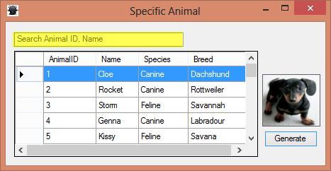

Select a animal by clicking anywhere on its row. You will see a picture of the animal on the right. Once you are satisfied with the animal you have selected click on the "Generate" button.

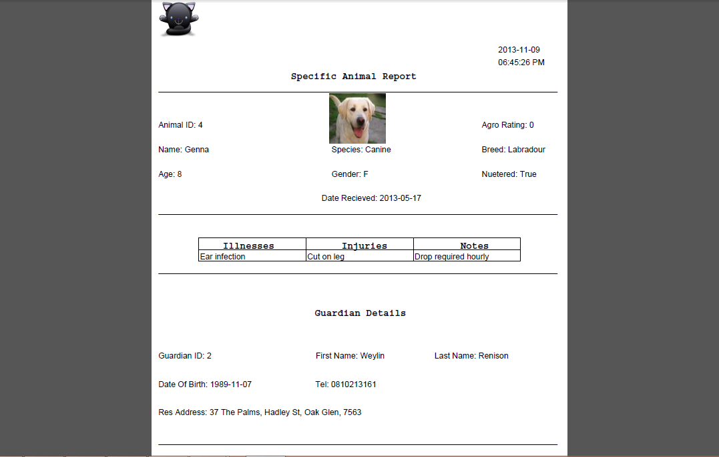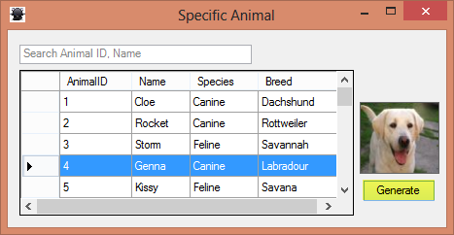

You will now be presented with a pdf report opened in your computer's default pdf program.

This report will have been saved to your default save directory that you have selected the first time the program was ran.

## Adopted / Not Nuetred Report

Adopted Report - a report of all the animals that have been adopted by the shelter, so in other words the animals without guardians

Not Nuetered - a report of all animals that have not yet been nuetered.

These reports work in the same manner...

Select either from the menu and a report will be generated from where you can save them to pdf, word, excel or print them.

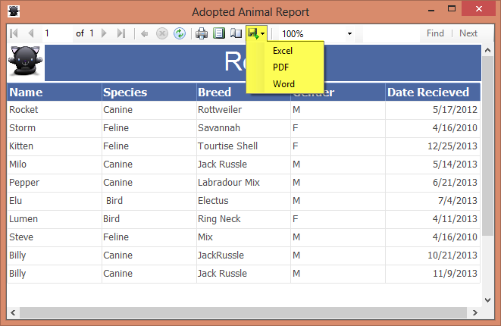

## Processed by specific Report

This report shows the animals that was added to the system during a particular month or a particular

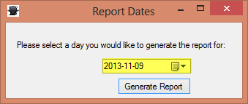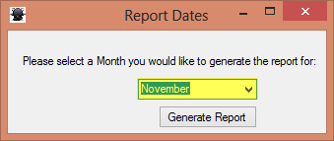day. Simply select which one you want, enter the month using the drop down box or select the specific day by using the date control.

Now click on the "Generate Report" button and a report is generated in the same manner as the adopt and not nuetered reports.

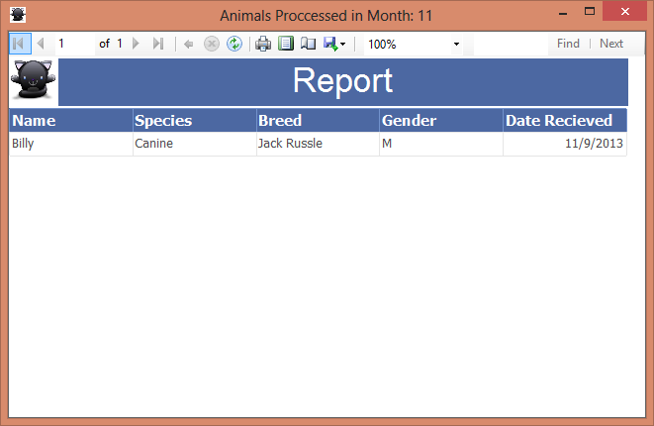

# Finding Application Options

The options for the application can be found by clicking on the File menu and selecting Options.

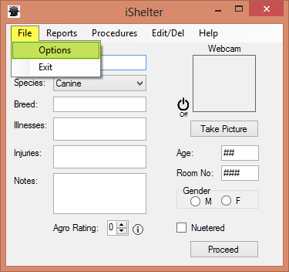

From here you can change the default save location for pictures and reports by clicking on browse and selecting a destination.

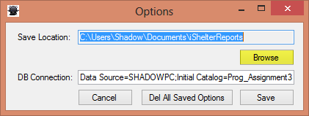

You can also change the connection to the database.

# Finding this user manual again

This user manual can be found again by clicking on the help menu and selecting Help F1 or by pressing the F1 key while using the application.

